

Fun Facts Compendium: Page 1

# Animal Oddities

* A group of flamingos is called a flamboyance.
* The only mammal that can truly fly is the bat.
* The heart of a shrimp is located in its head.
* Did you know that a snail can sleep for three years?

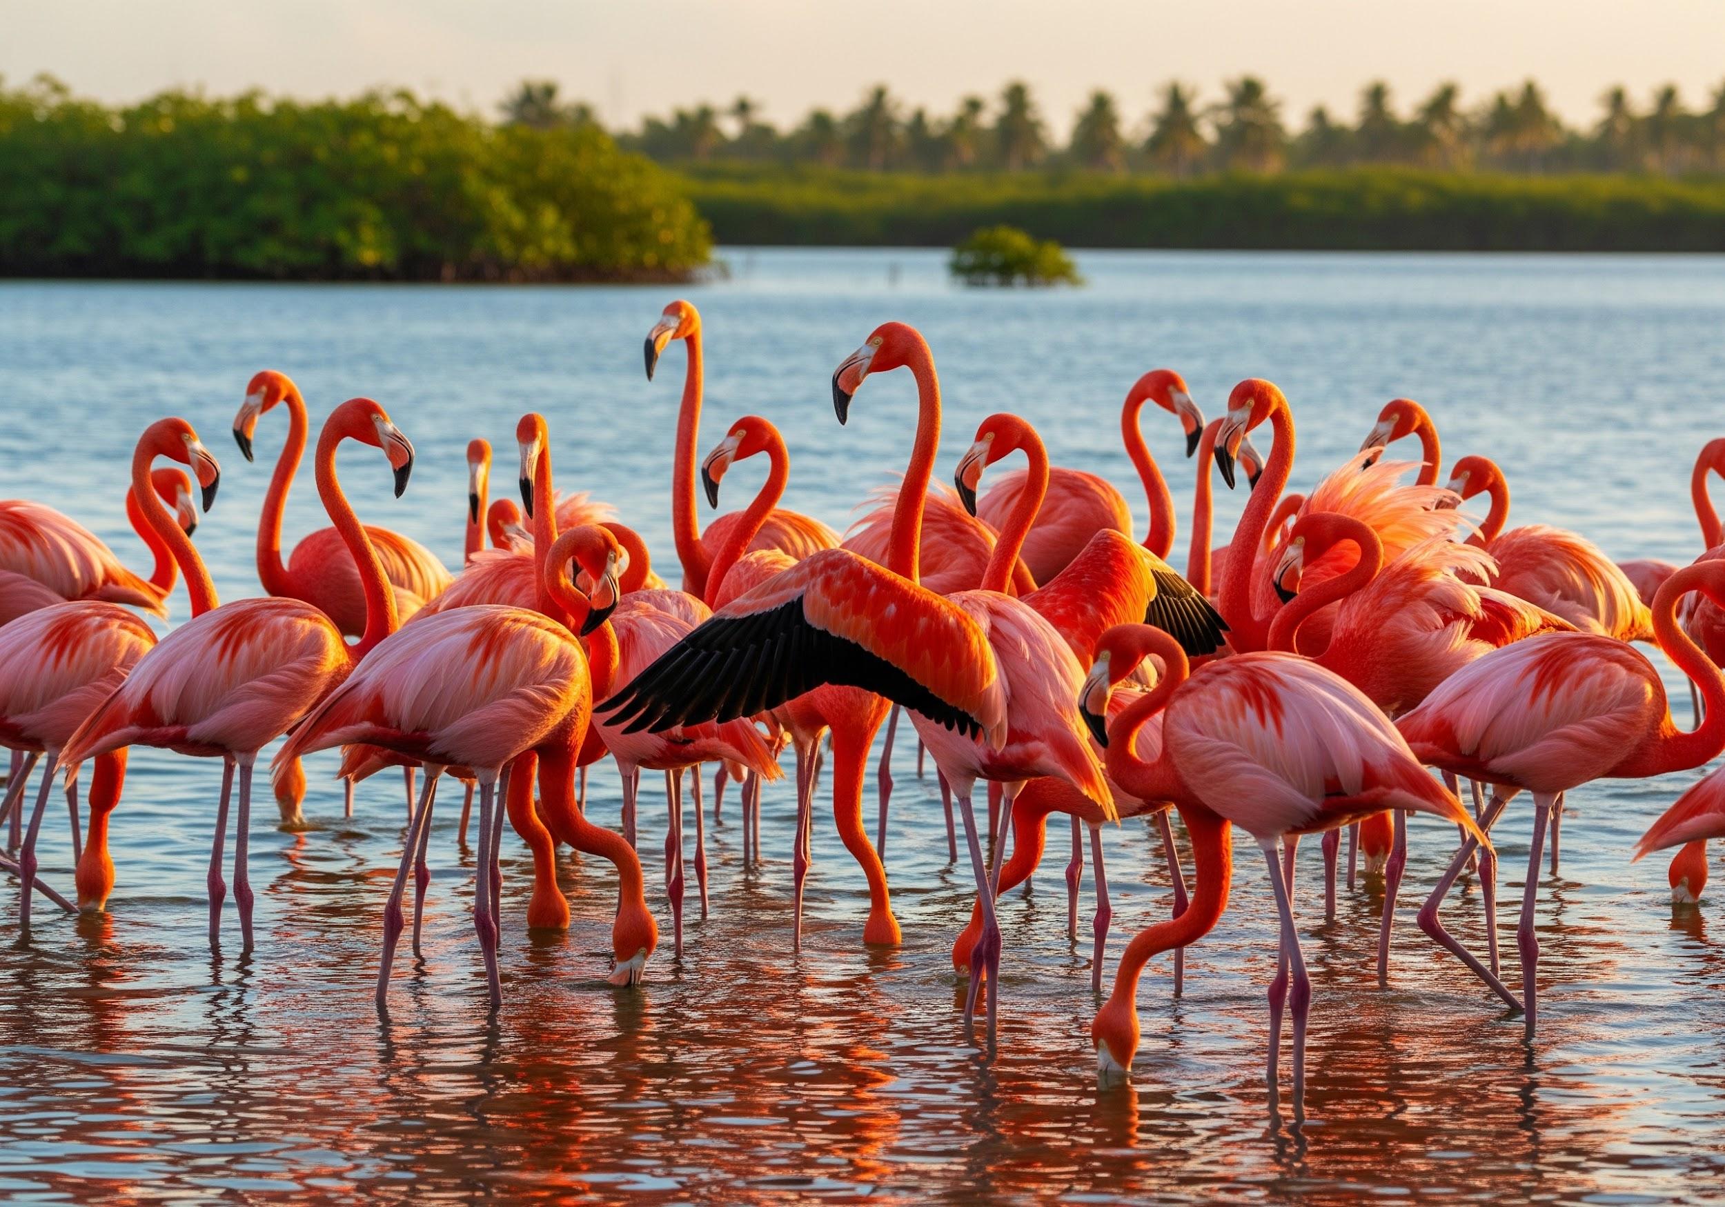

# Space Wonders

* There are more trees on Earth than stars in the Milky Way galaxy.
* The hottest planet in our solar system is Venus.
* One day on Venus is longer than one year on Venus.

Fun Facts Compendium: Page 2

# Food and Drink Trivia

* Pound cake got its name from its original recipe, which called for a pound of butter, a pound of sugar, a pound of flour, and a pound of eggs.
* Strawberries are the only fruit with seeds on the outside.
* 
* The fear of cooking is called Mageirocophobia.

# Human Body Marvels

* The average person walks the equivalent of five times around the Earth in their lifetime.
* Your nose can remember 50,000 different scents.

Fun Facts Compendium: Page 3

# Word Play

* "Rhythm" is the longest English word without a vowel.
* The word "set" has the most definitions of any word in the English language.

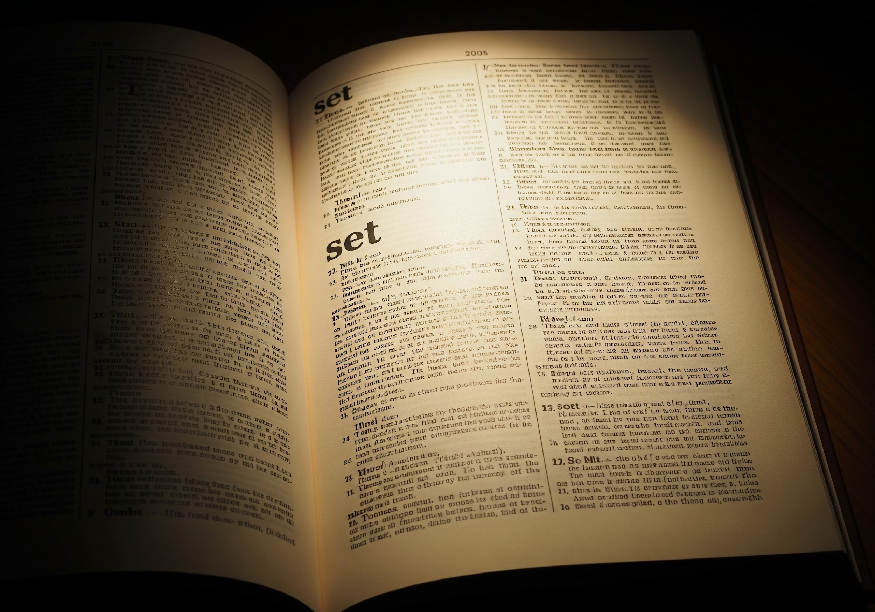

# Historical Quirks

* The shortest war in history was between Britain and Zanzibar on August 27, 1896. Zanzibar surrendered after 38 to 45 minutes.
* Before the invention of the rubber eraser, people used wads of bread.

Fun Facts Compendium: Page 4

# Nature's Delights

* Honey never spoils. Archaeologists have found pots of honey in ancient Egyptian tombs that are over 3,000 years old and still perfectly edible.
* 
* The northern lights (Aurora Borealis) can be heard, but only faintly, as a crackling sound.

# Architectural Wonders

* The Eiffel Tower can be 15 cm taller during the summer due to thermal expansion.
* It took less time to build the Empire State Building than it takes to apply for a construction permit in some modern cities.

Fun Facts Compendium: Page 5

# Inventions and Discoveries

* The inventor of the Pringles can, Fredric Baur, requested that he be buried in one. His children honored his request.
* The first computer mouse was made of wood.



# Random Knowledge

* The total weight of all the ants on Earth is roughly equal to the total weight of all the humans on Earth.
* The original name for the search engine Google was Backrub.

Fun Facts Compendium: Page 6

# Animal Powers

* A cat has 32 muscles in each ear.
* An octopus has three hearts. Two pump blood through the gills, and one circulates blood to the rest of the body.
* 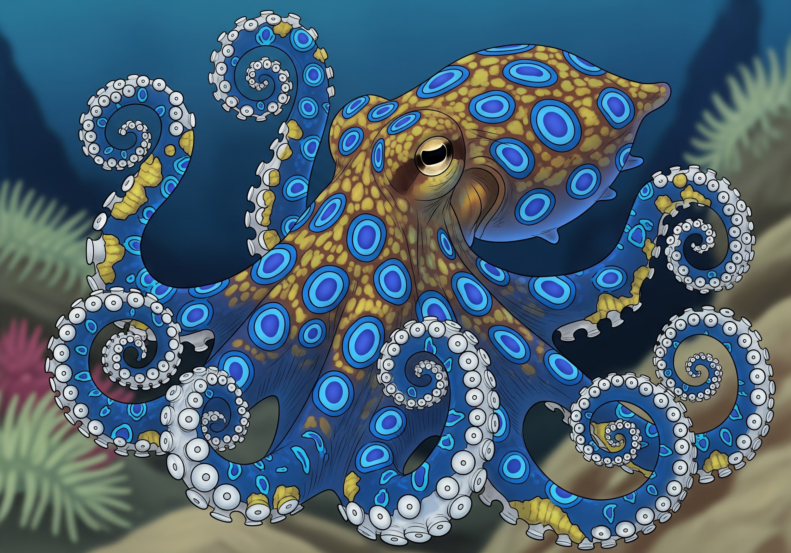
* Cows have best friends and get stressed when separated from them.

# Geographical Gems

* Mount Everest grows by about 4 millimeters every year.
* Istanbul is the only city in the world that is located on two continents (Europe and Asia).

Fun Facts Compendium: Page 7

# Movie Magic

* The actor who voiced E.T. was an 11-year-old girl.
* The sound effect for the "Lightsaber" in Star Wars was created by combining the hum of a movie projector and the sound of an old television's cathode ray tube.



# Science Surprises

* If you could drive to the sun at 60 mph, it would take you 173 years.
* The core of the Earth is hotter than the surface of the sun.

Fun Facts Compendium: Page 8

# Sports Facts

* The longest tennis match in history lasted 11 hours and 5 minutes and was played over three days.
* A golf ball has an average of 336 dimples.



# Everyday Wonders

* A cloud can weigh over a million pounds.
* It is physically impossible for pigs to look up at the sky.

Fun Facts Compendium: Page 9

# Fun with Numbers

* The number 4 is the only number that has the same amount of letters as its value.
* The opposite sides of a standard die always add up to seven.



# Name Origins

* The average lifespan of a taste bud is 10 to 14 days.
* The fear of long words is called hippopotomonstrosesquippedaliophobia.

Fun Facts Compendium: Page 10

# A Mix of the Bizarre

| Category | Fun Fact | Image |
| --- | --- | --- |
| Deep Ocean | The Pacific Ocean is wider than the Moon. | A side-by-side illustration comparing the width of the Pacific Ocean to the diameter of the Moon. |
| Sleep | Humans spend about one-third of their lives sleeping. | A person peacefully sleeping in a bed under a cozy blanket. |
| Music | The "Star-Spangled Banner" is only one of two songs in the world that can be heard only on the radio. |  |
| Trees | The tallest living tree is named Hyperion, a Coast Redwood in California. | A photograph looking straight up the immense trunk of a very tall redwood tree, emphasizing its height. |
| Time | Leap seconds are occasionally added to coordinate clocks with the Earth's slowing rotation. |  |

* Thank you for exploring this compilation of random fun facts!
* For more interesting information, you can always visit your local library or search online.